STAAR Online State Assessment Vs. the www.Kurzweil3000.com Text – to – Speech Program
STAAR Online | www.Kurzweil3000.com
STAAR Online  Text-to-Speech  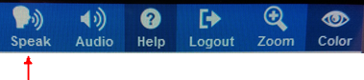  To have STAAR Online read aloud, the student clicks the “Speak” icon. A reading tool window pops up. From there they can click play, stop, or click word to hear single words read. They click close to close the reading tool window.  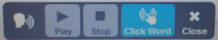 | Kurzweil  Text-to-Speech  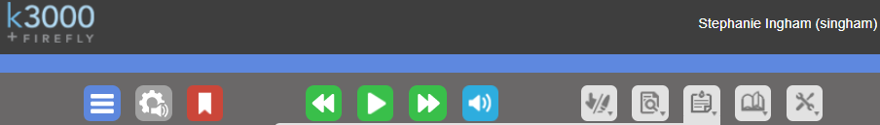  The Kurzweil read button is always present. To hear, the student clicks the read button. As it is reading, the play becomes pause . They click pause to stop. If they want to go back or skip forward they click . They can also click on the page where they want to start reading, click read and it will read. The is to turn on and off text-to-speech. The student can click the speaker button to turn it to silent . When they click read it only highlights to assist the student with tracking and does not read out loud. Click the icon again to turn on text-to-speech.
STAAR Online  Audio Options  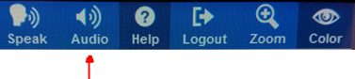  To change STAAR Online audio options, the student clicks the “Audio” icon. An audio settings tool window pops up (shown below). From there they can change volume and reading speed. 10 reading speeds available. STAAR Online currently has one voice available.  STAAR Online  Audio Options (continued)  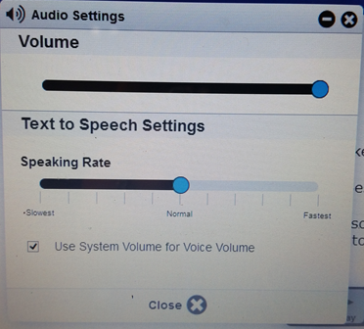 | www.Kurzweil3000.com  Audio Options  To change Kurzweil audio options, the student clicks on audio options . An audio options drop down appears to change the reading speed, voices, mode, and units. 20 reading speeds available. Volume is changed at the computer, not in the Kurzweil program.  www.Kurzweil3000.com  Audio Options (continued)  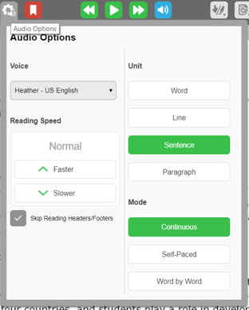
STAAR Online  Zoom  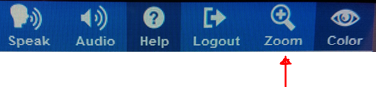  To change STAAR Online zoom options, the student clicks the “Zoom” icon. A zoom settings tool window pops up (shown below). From there they can change zoom and arrow across the page.  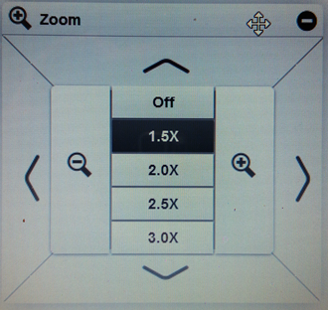 | www.Kurzweil3000.com  Zoom  To change the zoom in Kurzweil, click the Document View button, Slide the bar left/right to Zoom in or Zoom out.  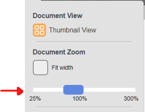
STAAR Online  Color Settings  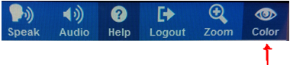  To change STAAR Online color options, the student clicks the “Color” icon. A color settings tool window pops up (shown below). From there they can change the background color or text color.  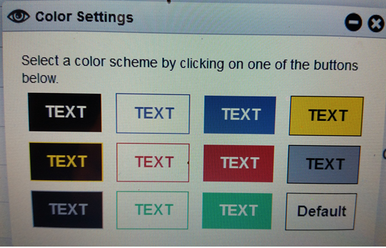 | www.Kurzweil3000.com  Color Settings  To change Kurzweil background color options, click on the tools icon , then click dropdown under “Background Color’.  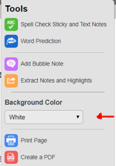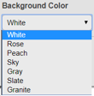  If the student is logged into their own Kurzweil account, it will remember their background color setting and they will not have to change them in other documents.
STAAR Online  Highlighter and Eraser  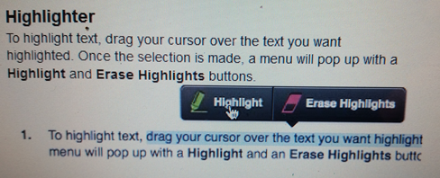  In STAAR Online, students left click and drag their mouse over the text to have the Highlight/ Erase Highlight menu appear. | www.Kurzweil3000.com  Highlighter, Cross-out and Eraser  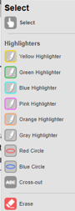  In Kurzweil3000.com, students can select the highlighter or eraser from the select button in the toolbar, select the tool and drag their mouse over the text to highlight, cross out or erase highlight. After using the tool, select the Select button to stop marking and bring the curser back.
STAAR Online  Notepad  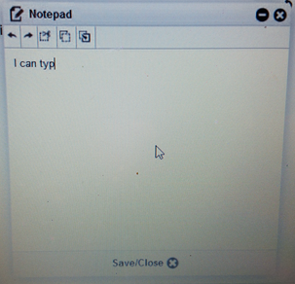  STAAR Online Notepad allows for taking note on each page. | www.Kurzweil3000.com  “Sticky note” similar to “Notepad”  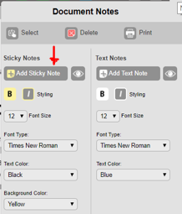  Stick Note is a similar tool in Kurzweil for the STAAR Online Notepad.  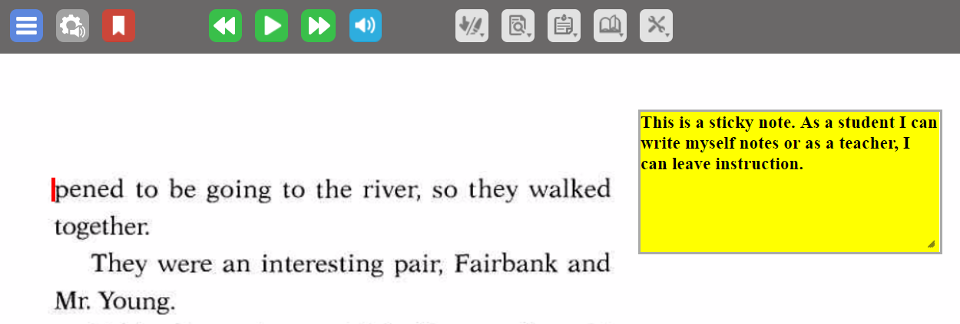  Students can click Notes button in the toolbar, select Add Stick note, then click on a blank part of the page, type in the note, then be sure to change tool back to select so that the student does not continue to drop additional sticky notes in the document. This is also where the student can change the font size if the text is too small
STAAR Online  Picture Support  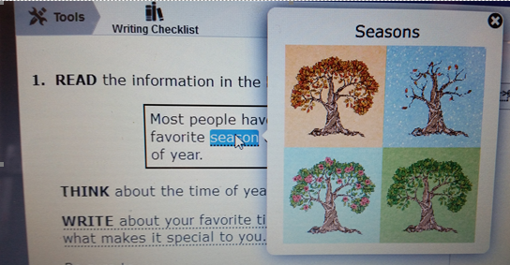 | www.Kurzweil3000.com  Picture Support  A teacher may paste any image into a bubble note “pop up” for picture supports by clicking the tools icon, clicking add bubble note, and pasting the picture into the bubble note.  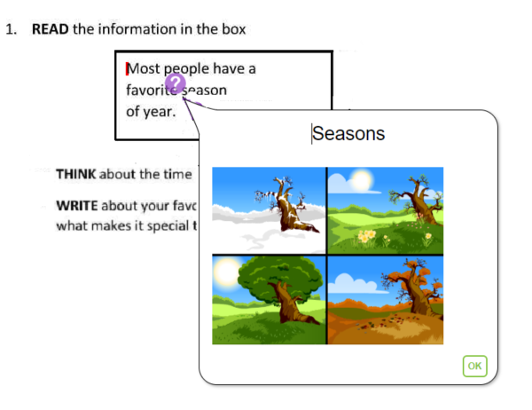
STAAR Online  “Pop-ups”  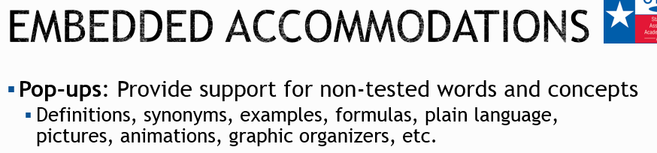  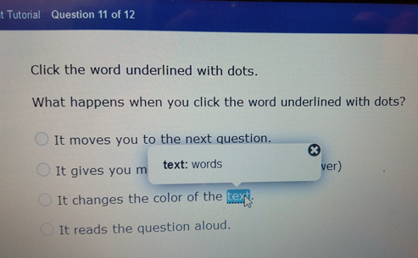  Sample of a pop-ups | www.Kurzweil3000.com  “Bubble Notes” similar to “Pop-ups”  Teachers can create bubble notes(similar to pop-ups) by placing their curser where they want to add the support, click “Tools” , click “Add Bubble Note”. Type the support. You can click options to not have Kurzweil read the bubble note or open unless prompted by student. Once finished, click “Ok”. You will see a marking where a support is embedded. When double clicked, the support opens. NOTE: Bubble notes is also what you would use for roll-overs, though it will not roll over the text.  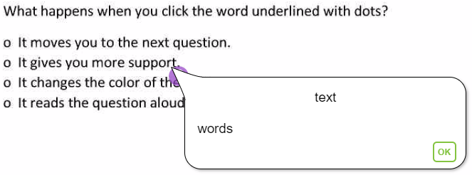
Kurzweil 3000 Web Client install
Marking sections of text not to be read, save lock features and password protect document

Documents and tests are commonly created with the Kurzweil 3000 Web client install. Teachers can mark sections of text to not to be read, edit for recognition errors, lock features in documents, and password protect the document. For more information on doing this go to www.kurzweilaustin.com, hoover over Kurzweil3000-firefly, click on Videos/Support.
OTHER SUPPORTS
Kurzweil :
Students have access to a variety of supports from the “Reference” button.

Definitions
www.Kurzweil3000.com

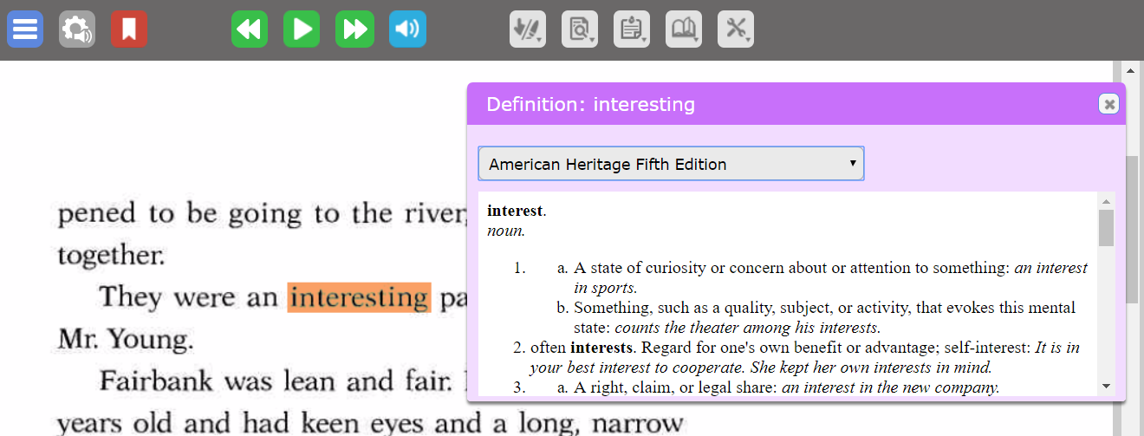
Students can select the dropdown menu to have access to these dictionaries (American Heritage Fifth Edition, American Heritage Children’s, and American Heritage College Writer’s Dictionary).
Translation
www.Kurzweil3000.com

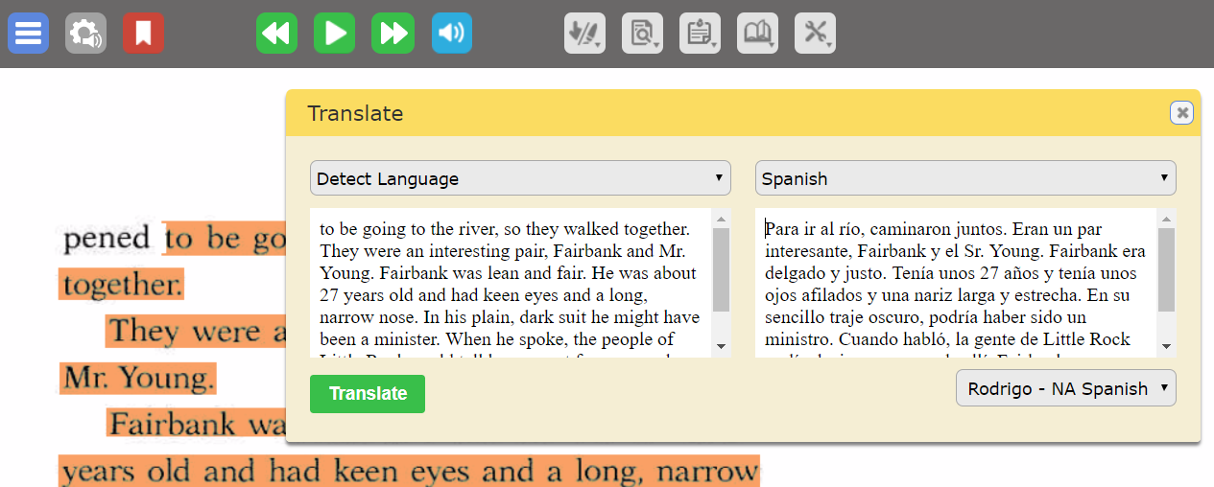
For language translation, students select the text, click the dropdown menu “Online”, and click “Translate” to translate from English to one of 80 languages. Kurzweil will read only 11 languages of the 80 languages it visually translates.
Audio Optical Systems of Austin
Ph# 512-454-8672
Email: aos@kurzweilaustin.net, www.kurzweilaustin.net
Created and revised by Stephanie Ingham 10/20/2017

