Kurzweil3000.com Document Editing for Optimum Reading Accuracy
(Especially Important for Test-Taking)
Task | Instructions
Locate the document | Locate the document that you wish to bring into Kurzweil3000.com as an image document. If it is not a PDF, open the document in its original application (i.e. Word, PowerPoint, etc); go to File/Save As, and save the document as a PDF.
Login | Login to Kurzweil3000.com (www.kurzweil3000.com)
Bring the document into Kurzweil3000.com | Open the desired image document using the following buttons: Google Drive, Computer, or Upload. (If you select Computer, the document will open and be automatically saved to your Recently Opened Local Files Folder. To select Upload, you’ll navigate to the folder in which you wish to save the document (your Private or Public), then click Upload. The document will not open, but will be uploaded to the specified folder. To open it, navigate to the document and open it.  Save: As a teacher, it is wise to save a copy of the original document in your Private folder or other location that is inaccessible to students. You can use the Copy button to create an additional copy of the file to manipulate.
Read/Listen  Audio Options | Listen to Kurzweil 3000 read the document aloud so that you can identify potential reading errors.  You may wish to turn up the reading speed while reading to hear errors, as you are not reading for understanding, but only to pick up on errors.
Edit for Optimal Reading Accuracy  Tools Menu | The Zone Editor and the Edit Underlying Text editor are both located in the Tools Menu. It is recommended that you Zone Edit first, then Edit Underlying Text next. Note: These are tools that can be locked for students under My Account/Users/My Team/Miscellaneous Feature Locks.  The document must be in one of your folders in order for you to edit with either the Zone Editor or Edit Underlying Text.  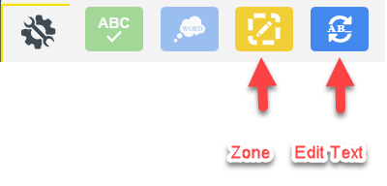
Zone Edit the Document | Zones determine what is read and reading order in an image document. The Zone Editor allows you to change the properties and reading order of zones, adjust the size of a zone to determine how much text it encloses, add new zones, delete zones, or designate silent zones. Hovering over a selected zone provides the user with information regarding the properties of that zone. Likewise, hovering over the list of the types of zones in the zone editor on the right will also produce a tooltip. Zones can be moved and resized as needed. Zone editing should be done before adding highlights or notes to a document. The Header/Footer Editor allows you to determine if those will be read. The Override OCR allows you to type what you want to be said without having to change the text one number or word at a time, handy to use with math editing.  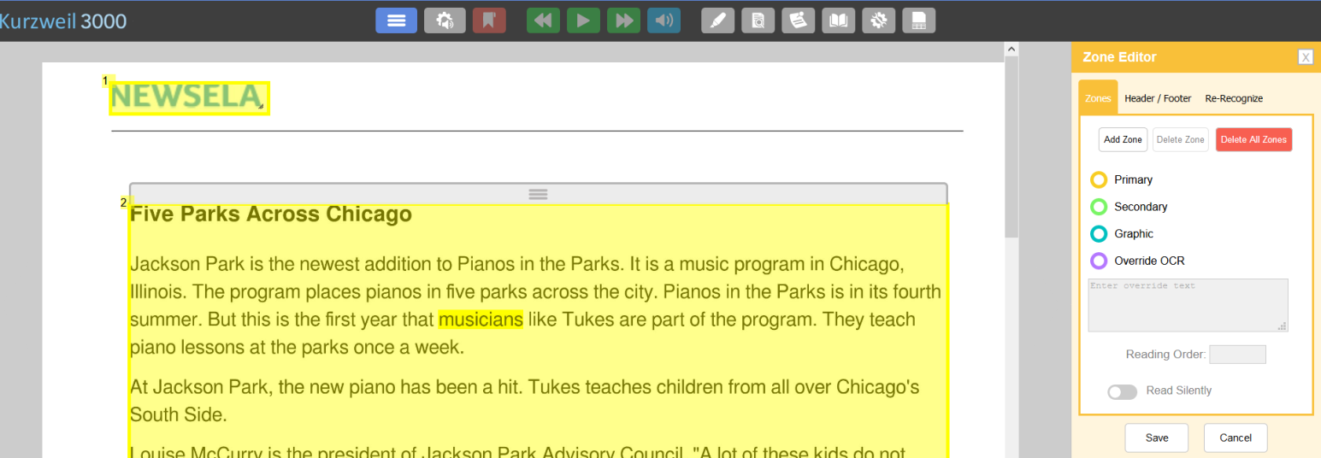
Edit Underlying Text | The Edit Underlying Text feature allows users to correct pronunciation in image files. When activated, the underlying text file that Kurzweil 3000 is actually reading will show at the bottom of the screen. The user selects the word that is being mispronounced in the document and then spells out the correct pronunciation in the “selected word” field at the bottom.  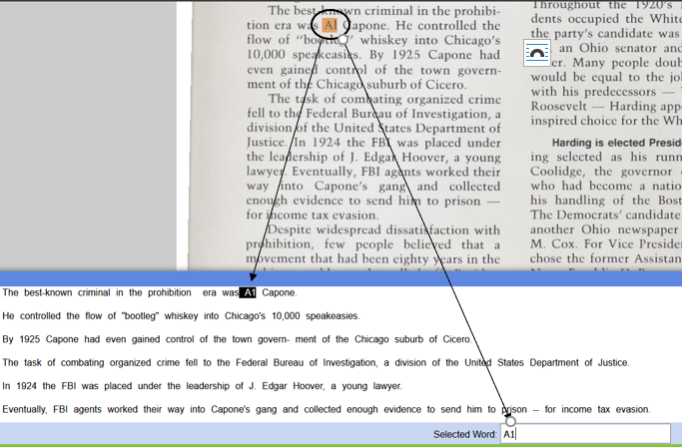  In the example above, the name “Al” (as in Al Capone) was recognized and pronounced as “A1.” To correct, simply type the correct spelling (or, in some cases, the phonetic spelling) of the selected word in the “Selected Word” field at the bottom. Once changes have been made, close the Underlying Text Windows and save changes.
Miscellaneous Feature Locks  Feature Locks | To lock Bubble Note Editing, Zone Editor, and Edit Underlying Text for the students on your team, go to My Account/Users/MyTeam (it will be yellow)/Miscellaneous Feature Locks. Select those three features, then click Save.  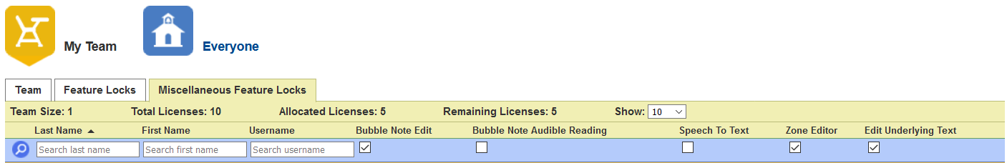  Features such as vocabulary supports, spell check and others can be disabled for students on a teacher’s team, which is especially helpful in a test-taking situation. Remember to reset feature locks once the test is completed.  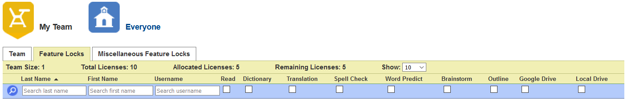
Password Protect  In the Document View menu | In a test-taking situation, it is a good idea to password protect test documents. This can be done through the Document View menu/Set Document Password. This will allow a teacher to copy a secure file into a student folder without risk of it being opened. It is advisable that teachers never give the document password to a student, but for the teacher to input that password. It is also advisable that the teacher keep a copy of the file that is not password protected in her/his private folder or in some other secure location as a backup.  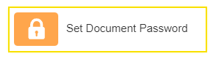  Important Note: There is no way to retrive a forgotten password , so make sure to record it reliably. Passwords can be changed by the owner of the document.
Copy the document to the student folders. Note: Use Copy to Multiple to send support notes and edits with document. | 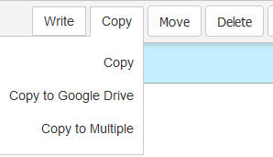  Click in the small check box to the left of the document name, then select Copy. The document can then be copied to individual student folders or to multiple student folders. To copy to an individual student folder, select Copy then navigate to that student’s Public or Private folder (or a subfolder within one of those).  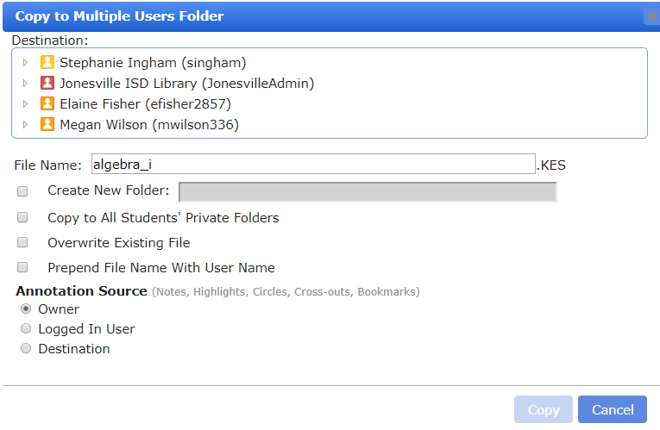  By selecting “Copy to Multiple,” teachers can copy a document to multiple student folders at one time. She/he can create a new folder, can copy to all student’s Private folders, or can select specific students to copy to. Copy to Multiple is also the way you insure the support notes and edits you added get copied with the document. You do not have to Copy to Multiple students to do this. If the document is in your private folder, click copy to multiple, then select your public folder to have the edits copy over. Notice Annotation Source “Owner” is auto bubbled to send notes with document.  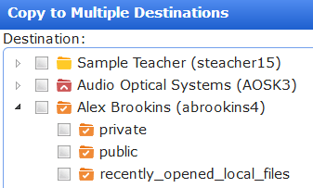  In order to manually select students to copy files to, you must expand the folder with the student’s name on it to access their Public and Private folders. Click on the triangle next to the student’s name and the subfolders will be revealed. If you try to save to the folder with the student’s name, you will receive an error message “You don’t have access to copy to this folder.” Click on the triangle next to the student’s name and the subfolders will be revealed.

